Create MYSQL database with particular VPC and port

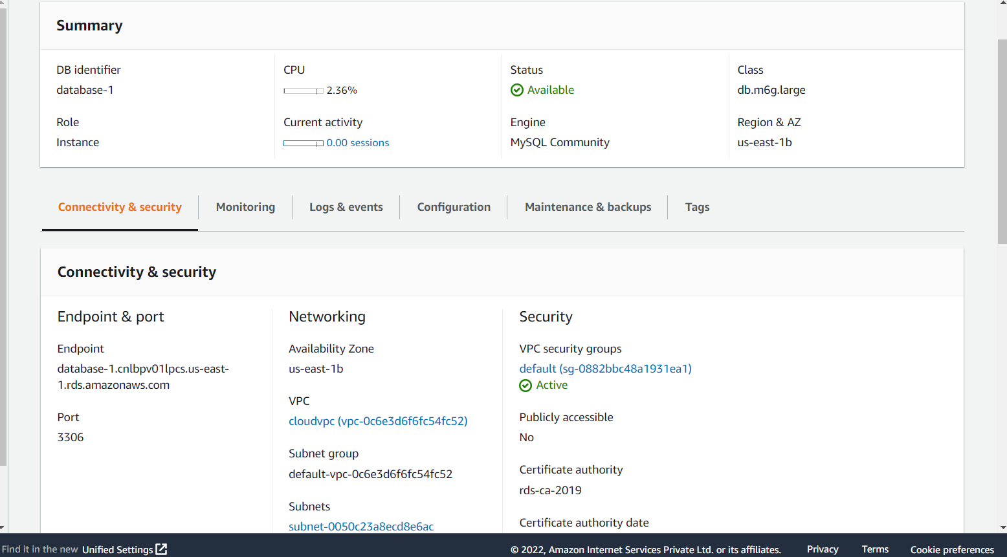

next we select the authentication password for the given data base.in the down we can find the username arn etc

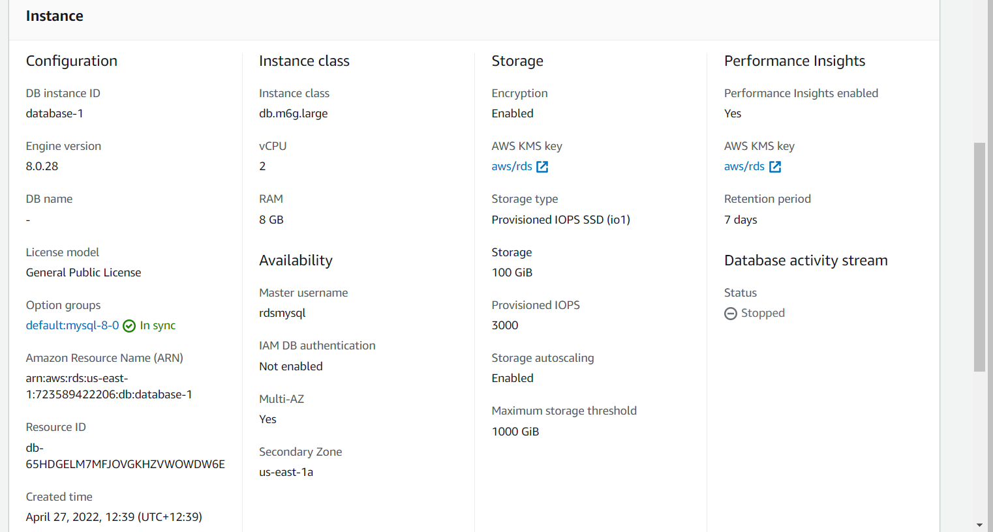

create the ec2 instance with AMAZON LINUX with free tier

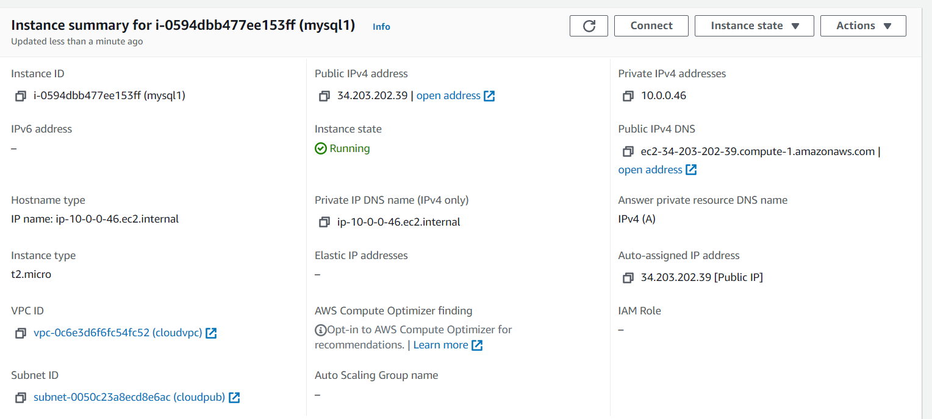

Next we select the security group with SSH and MYSQL with ports

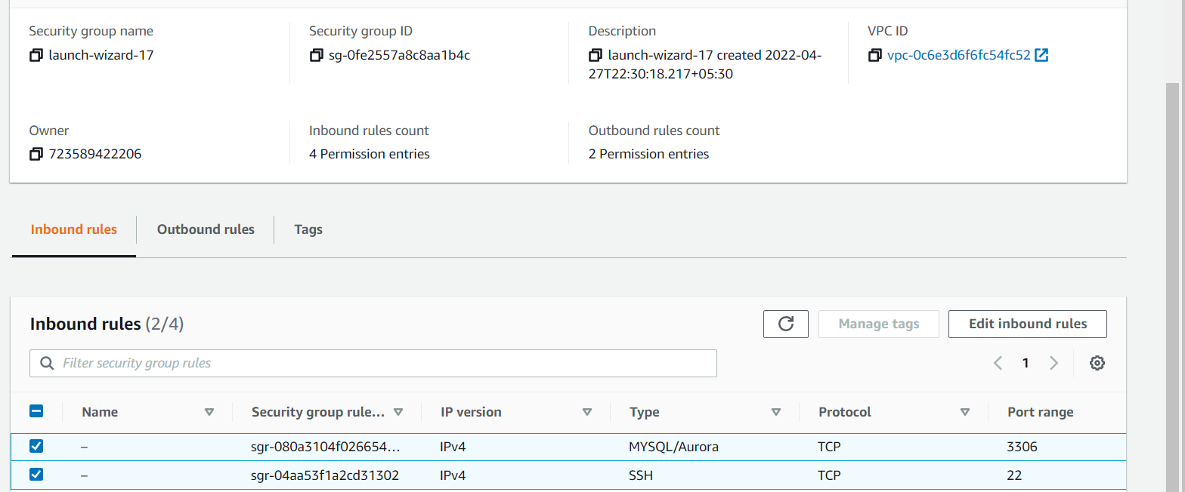

Select the putty and place the public address and ping the commands

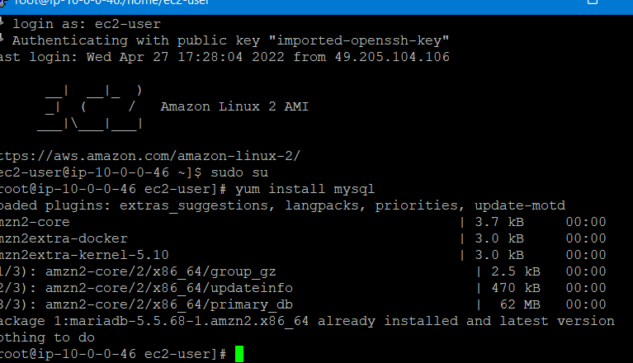

Next select the hostname with instance name

